**Submitted by : Spogmai Jan**

**Roll No : 2430 - 0081**

**Submitted to :Sir Bilal Dar**

**Subject : Programming Fundamental Lab**

**Lab Task 09**

**Task 01**: Write a C++ program to take a 4X4 2D array and print its value.

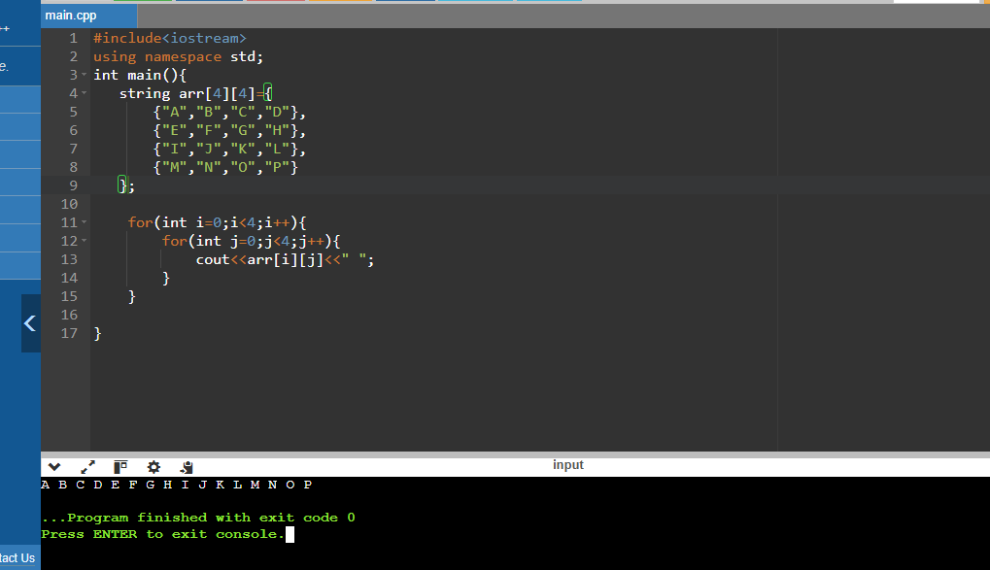

**Task 02:** Write a program to take a 3X4 2D arrays as an input and print its value.

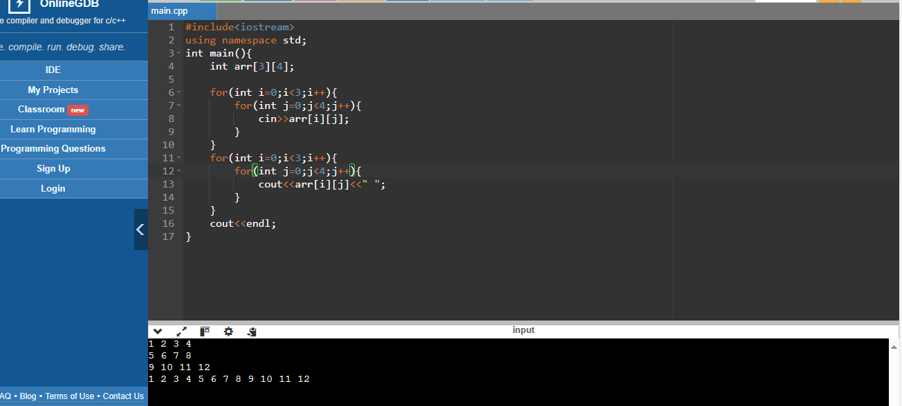

**Task 03:** Declare 2D array of size 3x3

.Take input from the user to fill the array

.Calculate the sum of all the elements in the 2D array

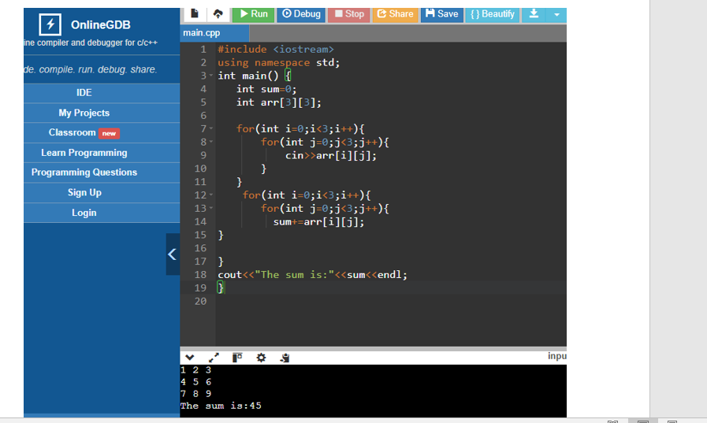

**-----THE END -----**